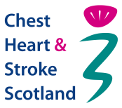
Introduction to Chest Heart & Stroke Scotland
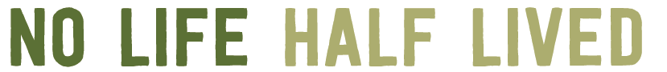

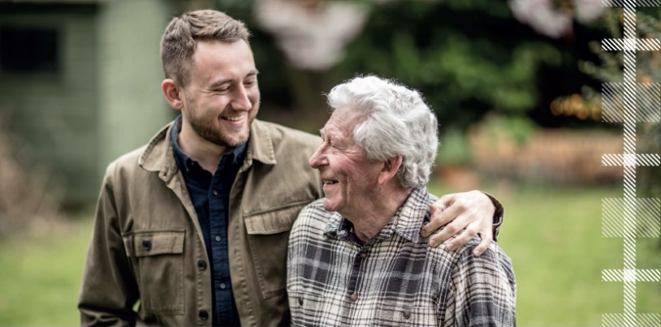
Everyone has the right to live life to the full. After a diagnosis of a chest or heart condition or a stroke, many people experience fear and isolation and struggle with the impact on their lives. Chest Heart & Stroke Scotland won’t stand for that. The care and support we deliver every day ensures everyone can live the life they want to.

Our Vision: welcome to a Scotland where people with our conditions can live their lives well. Full lives, with the right support, at the right time and in the right place. A place where you can shape your future and live the life you want to lead.
Our Mission: welcome to a community where people can support each other, secure the expert help they need and collectively advocate for the care that matters to them. Welcome to the charity that never underestimates the power of a cup of tea, a conversation started, a recovery begun.

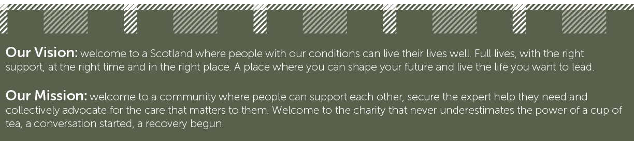

No Life Half Lived means we need to listen to people with our conditions and deliver well for them. We have identified four goals to get us there.
We will place our focus on addressing the unmet needs of people with our conditions - social, emotional, and physical - across all Scotland’s communities.
We will be led by our people: people with lived experience of our conditions, their families & carers, friends, colleagues and healthcare professionals.
We will secure the funding required to deliver via a diverse income portfolio that is consistent with our values and ethical approach.
We will be effective and accountable in all that we do
We have developed six values to guide us in delivering against our goals:
Agile: we will be able to adapt to the needs of our people and the environment we work in.
Innovative: we will look for improvement in what we currently do and be creative in developing new services.
Inclusive: we will adopt a human rights based approach to our work and ensure we are accessible.
Accountable: we will take ownership for our work and hold decision makers to their responsibilities.
Collective: we can only achieve our goals by working together and learning from each other.
Courageous: we will say what needs to be said and do what needs to be done to meet our goals.

Role Profile

The role profile is included on our recruitment page which you should refer to.

Summary of Terms and Conditions of Employment

Review of Work: The post holder is subject to the CHSS objective setting, supervision and appraisal process.

Annual Leave: CHSS leave year runs from 1st April to 31st March. Employees are entitled to 36 days annual leave in their first year of service (including public holidays). An employee will be awarded one extra day’s annual leave for each complete year of service up to a maximum of 42 days (including public holidays). These allowances are pro-rated for part time employees and further pro-rated for those who join or leave CHSS during the leave year.

Pension scheme: CHSS offers a Group Personal Pension Plan, which has been established with Aviva. The Plan is a money purchase arrangement. You can choose at what rate you wish to contribute (subject to a minimum age related contribution) and how to invest your own contributions and those made by CHSS. The emerging fund at the point that you wish to take the benefits is then used to purchase a pension that is paid for the rest of your life.

Employee’s and Employer’s Contributions are paid on the portion of the employee’s salary which is above the National Insurance contributions threshold (the Lower Earnings Limit). Employees who meet the relevant criteria are “automatically enrolled” in the scheme.

There are also schemes which provide death-in-service benefit and permanent health insurance.

Equal CHSS is committed to equality of opportunity and to no discrimination on
Opportunities: the grounds of race, religion or belief, age, sex, marital or civil partnership status, disability, sexual orientation, transgender status, pregnancy or maternity.

